MINUTES
MLDC REGULAR MEETING 02-09-2023
Location: MLDC Office and Possibly Virtual via Zoom

ATTENDANCE: Present: Fred Harding, John Lavelle, Kelly Teacher, Erika Malmgreen, Nicole Irwin, Dave Lybolt, Alex Goodman
Absent: None
CALL TO ORDER – 5:58 PM

FINANCIALLY IMPORTANT COMMITTEE REPORTS COMMITTE REPORTS
FARMERS MARKET(John Lavelle, Kelly Teacher, Fred Harding, Chris Wilson)
- Per e-vote contract signed with Chris Wilson to be Farmers Market Coordinator for period February through September at $500 per month ($4000 total).
- Kelly Teacher, Fred Harding and Chris met on February 3, 2023, to review Farmers Market Budget and create new one. (attached separately)
- Status update from Chris Wilson (Market Coordinator)
CALENDAR (Production 2023-Kelly Teacher)
- approved pricing structure and calendar format moved to ratify: Erika Malmgreen second: Dave Lybolt Vote: Unanimous
RATIFICATION OF E-VOTES AND PRE-APPROVED EXPENDITURES:
Action Taken: Moved ratification of following e-votes: Unanimous
- Authorize Chairman to sign Farmers Market Coordinator Contract with Christopher Wilson
- Approve Revised 2023 Budget Enabling Board to Move Forward with Hotel Feasibility Study Without Requesting Funds from Town.
Moved Acceptance: Nicole Irwin Second:Alex Goodman Vote: Unanimous

MINUTES: Approval of Regular Meeting of 01-12-2022
Action Taken: Moved Acceptance: Dave Lybolt Second: Erika Malmgreen Vote: Unanimous

TREASURER’S REPORT
(Bookkeeper JGS, CPA):
- Bank Balance – Checking - Operating Acct. as of 01-31-2023: $8,626.45 (see Exhibit B1)
- P & L – Checking – Operating Account Year to Date 01-31-2023 (see Exhibit B2)
- Balance Sheet – Operating Account – as of 01-31-2023 (see Exhibit B3)
Action Taken: Moved Acceptance: Alex Goodman Second: Nicole Vote:Unanimous
- SINCE 12-31-2022
Additional Deposits
None
Total = $0
Cleared and Outstanding Checks
Chris Wilson – February 1 Farmers Market Coordinator Fee
Total = $500
Other Transaction
None –
Total = $0
Available Balance as of 01-12-2023
$8,126.45
Encumbered
$1500.00 for scholarships from grant
Total = $1,500.00
Unencumbered Balance as of 01-12-2023
$6,626.45

PRESENTATION OF NEW AND CONTRACTUAL BILLS
- PFK O’Conner Davies - $150.00 for February bookkeeping (see Exhibit C1)
- Chris Wilson - $500 due February 1 as February Farmers Market Coordinator per Contract (attached separately)
- Chris Wilson - $500 due March 1 as March Farmers Market Coordinator per Contract
Action Taken: Moved Authorization to Pay Bills: Erika Malmgreen Second: Alex Goodman Vote:Unanimous

COMMITTEE REPORTS
FARMERS MARKET. $4000 to be approved for billboard, Fred to confirm deposit
First: Fred Harding Second:John Lavelle Vote: Unanimous
FINANCE (Fred Harding and Alex Goodman)
MLDC subsidization of the Farmers Market be reduced from the adopted January 13, 2023, budget from $5,840 to no more than $3,635
Moved to Accept: Alex Goodman Second: John Lavelle Vote: Unanimous
D&H TRANSPORTATION HERITAGE COUNCIL (Dave Lybolt)
GRANTS (Fred Harding. Etal.)
TRAIL APPS (Kelly Teacher, Fred Harding).
- Town Park - to combine Kohl’s grant with town grant for loop trail
Action Taken: First: Fred Harding Second: Nicole Irwin Vote: Unanimous
PUBLIC RELATIONS & SOCIAL MEDIA (Kelly Teacher, John Lavelle, Fred Harding).
BUSINESS PROMOTION (John Lavelle): Update on Hotel Feasibility Study
BUSINESS DEVELOPMENT

OTHER BUSINESS THAT MAY COME BEFORE THE BOARD.
- Terms Expiring February 13, 2023: Fred Harding, Kelly Teacher, Dave Lybolt.
A letter requesting reappointment has been sent to Supervisor Robbins.
- Resolution increasing Board from 7 to 9 Directors
Moved approval and submittal to Town: Dave Lybolt Second:Erika Vote: Unanimous

ADJOURNMENT at 6:49
Action Taken: Moved approval: John Lavelle; Second: Alex Goodman; Vote: Unanimous

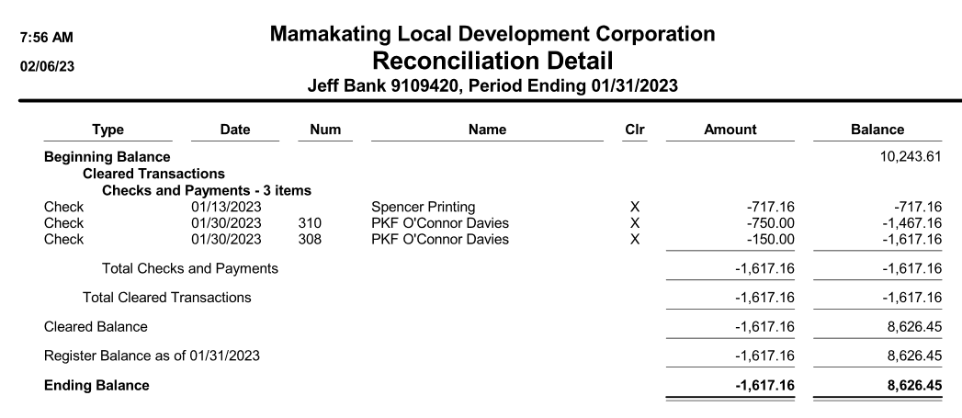
EXHIBIT B1

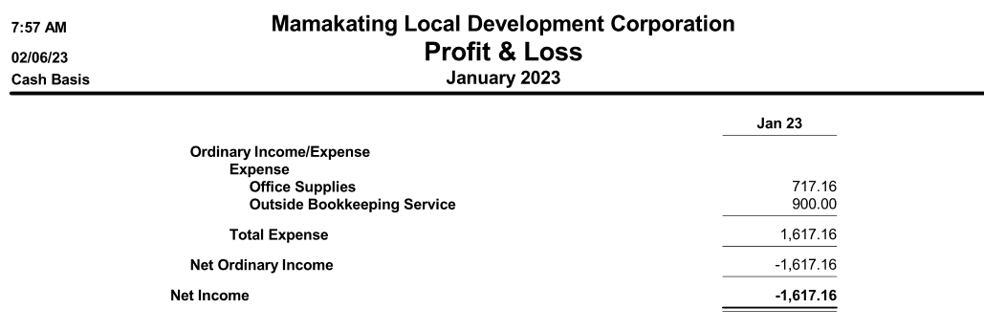
EXHIBIT B2

EXHIBIT B3
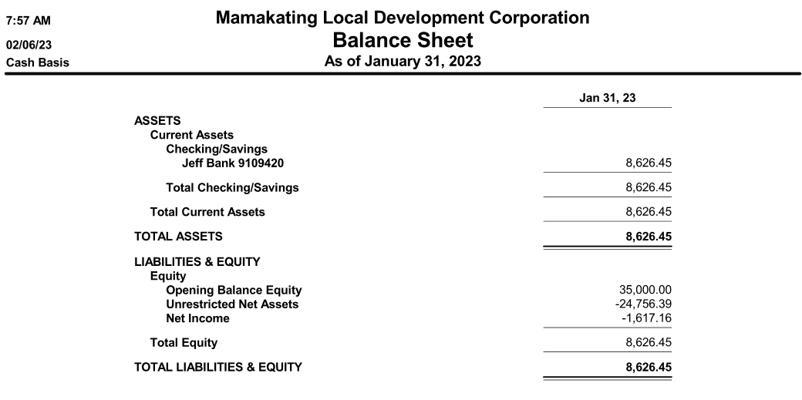

EXHIBIT C1
